Specific Heat Capacity

Lab Report - 24/01/2016

# Introduction

The objective of this experiment was to obtain the specific heat capacity of water, and then compare the experimental data gained with theoretically predicated data. The monitoring of temperature change will allow us to obtain the specific heat capacity of water.

# Theory

The specific heat capacity of a material describes the amount of energy that is required to heat 1 kg of the material by 1 degree in temperature.

The formula for specific heat capacity:

$c= \frac{Q}{m∆T}$**[1]**

Where $c$ is the specific heat capacity (in J/(kg°C), $Q$ is the change in heat content (in Joules), $m$ is the mass of material (in kilograms) and $∆T$ is the change in temperature (in Celsius).

The specific heat capacity for water is 4200 J/kg°C.

# Apparatus

The setup of the experiment was as follows:

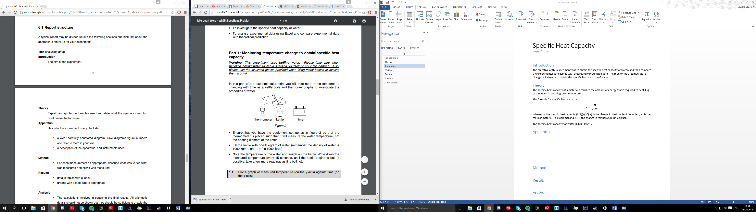

*Figure 1*

* Kettle
* Thermometer
* Timer
* Water (1kg)

# Method

Firstly note down the power rating of the kettle. Then continue to fill the kettle with water until it reaches the 1 Litre mark on the kettle (as the density of water is 1000 kgm-3).

Place the thermometer inside the kettle, ensuring that it will measure the temperature of the water and not the heating element of the kettle.

Before switching on the kettle, note down the initial temperature of the water. Switch the kettle on and continue to note down the temperature of the water every 15 seconds until the kettle begins to boil. Proceed to graph the data.

Then use the recorded temperature data and the power rating of the kettle to calculate the energy applied to heat the water. Proceed to graph the results and calculate specific heat capacity.

# Results

|  |  |
| --- | --- |
| Time (s) | Temperature (°C) |
| 0 | 17.0 |
| 15 | 18.3 |
| 30 | 25.9 |
| 45 | 33.2 |
| 60 | 40.4 |
| 75 | 47.6 |
| 90 | 54.4 |
| 105 | 62.0 |
| 120 | 67.8 |
| 135 | 74.3 |
| 150 | 81.5 |
| 165 | 87.7 |
| 180 | 94.5 |
| 195 | 99.5 |
| 210 | 99.6 |

|  |  |  |
| --- | --- | --- |
| Time (s) | Temperature (°C) | Energy (kJ) |
| 15 | 18.3 | 33 |
| 30 | 25.9 | 66 |
| 45 | 33.2 | 99 |
| 60 | 40.4 | 132 |
| 75 | 47.6 | 165 |
| 90 | 54.4 | 198 |
| 105 | 62.0 | 231 |
| 120 | 67.8 | 264 |
| 135 | 74.3 | 297 |
| 150 | 81.5 | 330 |
| 165 | 87.7 | 363 |
| 180 | 94.5 | 396 |
| 195 | 99.5 | 429 |
| 210 | 99.6 | 462 |

As both graphs form a straight line, by taking 2 points from the Energy against Temperature graph we can calculate the specific heat capacity of water. Using the following formula:

$m= \frac{y_{2}-y_{1}}{x_{2}-x_{2}}$**[2]**

The gradient/specific heat capacity is **4.99 kJ/kg°C**.

# Analysis

To calculate the Energy applied to the water, the formula below was used:

$$P= \frac{E}{t}$$

And rearranged to:

$$E=Pt$$

Where $P$ is the power (in Watts), $E$ is the energy (in Joules) and $t$ is the time (in seconds). To make the gained data shorter, the energy in Joules was converted into Kilojoules. Assuming the power of the kettle to be 2200 W (within the quoted range on the kettle).

Once the energy was calculated for each temperature this was then graphed where we saw that it forms a straight line. Therefore using formula **[2]** along with 2 points from the graph we calculated the gradient which gives us the specific heat capacity of the water:

$$m= \frac{y_{2}-y_{1}}{x_{2}-x_{2}}$$

$$m=\frac{429-33}{99.5-18.3}$$

$$m=4.876…$$

$$m=4.9\frac{kJ}{kg}°C$$

# Conclusions

In the Temperature against Time graph we found that it features a straight line up until the boiling point of the water. The gradient of the line is constant as the water increases in temperature with time, until boiling point.

Continuing on with the creation of the Energy against Temperature graph, it also produces a straight line as the amount of energy increases so too does the temperature.

In conclusion, the value we gained was an over-estimate as the specific heat capacity of water is 4.2 kJ/kg°C not 4.9 kJ/kg°C. This could be due to the efficiency of the kettle and also the power rating of it. When noting down the power of the kettle it had a range of 1850 W – 2200 W. In our calculations we used 2200 W, so the true power may be less than that.

When completing this experiment again we could complete it multiple times to then work out a more accurate value and use the median of the range as the rated power for the kettle.